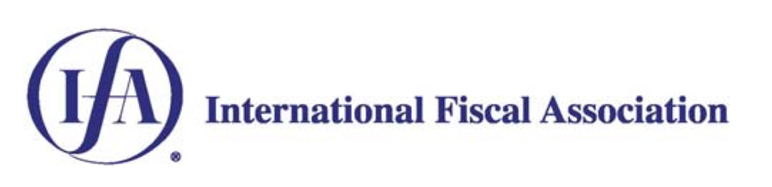

The Young IFA Network is pleased to invite you to the following online event:

Topic | International tax arbitration in a post-BEPS world  Panel discussion
Details | Since the commencement of the OECD's project to address base erosion and profit shifting ('BEPS') in the early 2010s, there have been growing calls from the taxpayer community for mandatory binding arbitration to resolve the proliferation of double tax disputes, especially in the area of transfer pricing. With the signing and subsequent ratification of the OECD's Multilateral Instrument ('MLI'), mandatory binding arbitration is increasingly become a relevant consideration for taxpayers. The Young IFA representative of the Australian branch, Thomas Ickeringill, will chair a panel discussion that explores the new world of international tax arbitration.
Date and time | Thursday, 3 September 2020, 6pm AEST  Live broadcast from Australia, New Zealand and the UK
RSVP | Please confirm your attendance by emailing Sam Lacey on sam.lacey@allens.com.au.
Joining | This event will be hosted through Microsoft Teams. We recommend that you log in five minutes prior to the event.  To join via laptop: Please select join the meeting when ready. If you are not a Microsoft Teams user, you will be prompted to join the app which we recommend for the best experience. If you are having difficulty downloading the desktop app, there is an option to join in your browser.  To join via phone: Please download the Microsoft Teams app from the App Store before joining the meeting.  If you would like any assistance or are having difficulty joining the discussion, please contact Sam Lacey on 0450 122 561.
 | Martin Fry (Allens, Partner)  Martin is the Practice Leader of Tax at Allens in Australia. He advises clients on a broad range of taxation issues, with particularly strong experience in transfer pricing disputes, including audits, mutual agreement procedure and litigation.
 | Sarah Blakelock (Slaughter and May, Consultant)  Sarah is an experienced tax adviser with a wealth of Australian and UK experience in domestic and international tax disputes and advisory. Sarah will be able to share her expertise, particularly in respect of arbitration under the EU Arbitration Convention.
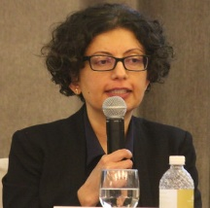 | Kriti Velji (Ernst & Young, Associate Director)  As a former NZ Competent Authority, Kriti has unrivalled experience in negotiating MAP outcomes with New Zealand's treaty partners. More recently, Kriti has worked as a UK and trans-Tasman adviser to taxpayers, assisting with APAs, MAPs and complex tax disputes.
 | Simon Hellmers (ATO, Assistant Commissioner)  Simon has many years of experience working with the ATO, with a particular focus on MLI implementation and management of the APA programme. More recently, Simon has had the responsibility of leading the negotiations of Australia's arbitration procedures with its treaty partners.
 | Thomas Ickeringill (Allens, Senior Associate)  Thomas is the Australian Young IFA representative. He has a wealth of experience in the resources and technology sectors in both Australia and the UK, particularly in complex international corporate tax and transfer pricing disputes, advisory and planning.

